March Mathness Worksheet 2

Mathematica tutorial

Due Date: February 11th, 11:59PM

In this Module, you will download your own free copy of *Mathematica* from the OIT website. Follow these steps to download *Mathematica* 9*.

* Go to the OIT homepage:
  + - http://oit.nd.edu/
* Click on *Software Downloads* in the menu on the left.
* Enter your Notre Dame netID and Password in the fields provided.
* Look for *Mathematica* on the list of available software.
* Click on More Details and follow the directions to download the Student Version.
* When you open *Mathematica*, you should open a new Notebook by clicking on File in the menu bar, then follow the path File/New/Notebook. You can also create a new Notebook, by pressing **Command+n** or **Ctrl+n** on your keyboard.

The *Mathematica* window will look something like this:

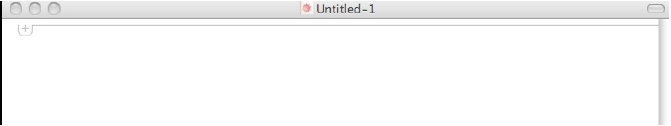

To enter a command, click on the plus mark in the upper left of your document and choose *Mathematica* input from the drop down menu. Note that this is also the default mode, so you can just start typing your command without this step, if you click below the plus mark.

Type **2 + 3** and press ***Shift+Return*** to get your answer 5 on a new line.

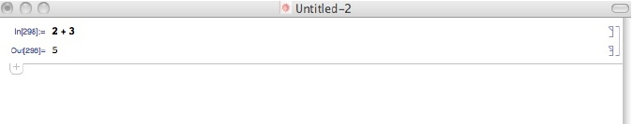

* Version 9 is most current as of 2/28/13. Newer versions may be available in time since then. Commands will not vary greatly between version, if at all.

Another way to Evaluate a command in an input cell is to click anywhere on the code in the cell, go to *Evaluation* in the menu at the top of your screen and choose *Evaluate* *Cells* from the drop down menu.

To solve a system of linear equations in *Mathematica*, we will use their matrix form.

We first learn how to enter a matrix and give it a name. We represent the matrix as a list of rows separated by commas between curly brackets. Each row is enclosed by curly brackets with commas separating the entries.

**Example:** The matrix

should be entered as:

{{2,3,4},{1,1,1},{1,5,10}}

When you enter this matrix as input, press ***Shift+return*** to get:

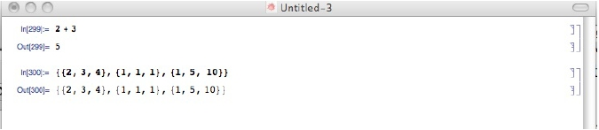

The output, looks exactly like the input. if you prefer the usual matrix format, we will discuss how to view that below. If we want to use this matrix in calculations, we must be able to refer to it, so we must give it a name. To call the matrix *m*, we can go back to the input cell and simply insert *m* = in front of our matrix. Then we press **Shift+Return** to get the same output, except now *Mathematica* knows that this matrix is called *m*. If you wish to view your matrix in the usual format, you can type the command **MatrixForm[m]** and *Mathematica* will present the matrix in its usual form.

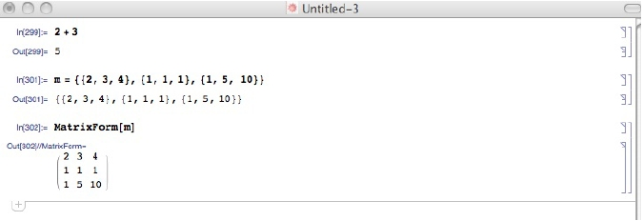

Now suppose (as we already have done in class), we wanted to solve for X in the matrix equation:



then we need to solve for the matrix **X** in the equation:



Lets call the matrix on the right **b** and enter it into *Mathematica*. Note there is just one entry in each row.

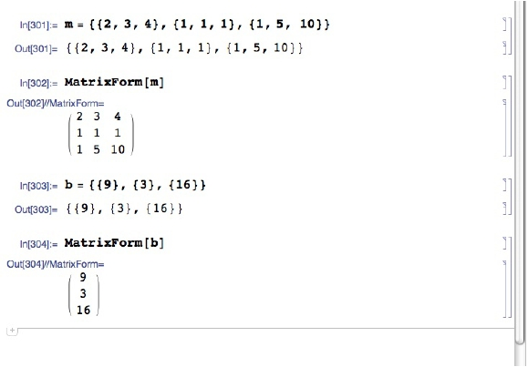

Now to solve the system, we must solve for the matrix X the matrix equation **mX = b**. To do this in *Mathematica*, we use the command **LinearSolve[m,b].**

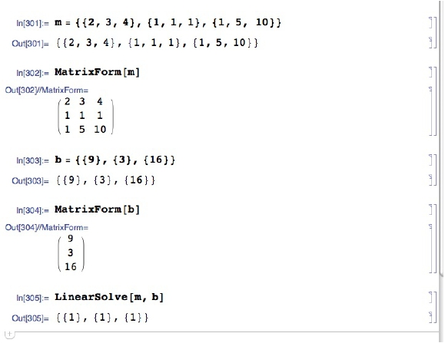

The output is the matrix **X**, we can view this matrix in matrix format if we change our command from **LinearSolve[m,b]** to **MatrixForm[LinearSolve[m,b]]**. We see that:



To save your file, use **Command-S** or **Ctrl-S**. The first time you save the file, you will need to supply a name and choose where to save it.

**Assignment:**

* Watch Lectures 4 and 5 from Tim Chartier on Udemy
* Complete the following practice *Mathematica* examples*.*
* Update your Worksheet 1 spreadsheet that tracks your assigned conference
* Send your saved *Mathematica* files and your updated conference tracking spreadsheet to your TA by Midnight of the 11th.

**Example** Convert the system of linear equations shown below to a matrix equation of the form AX = B and solve the system using *Mathematica*.



**Example** Convert the system of linear equations shown below to a matrix equation of the form AX = B and solve the system using *Mathematica*.

